Artículo
Plantilla de artículo académico de Estudios Iberoamericanos
An academic article template of Ibero-América Studies
Autor A ¹ and Autor B ²
¹ Editorial de Ibero-América Studies, University A, Spain; iberiamerica@gmail.com
² Editorial de Ibero-América Studies, University A, Spain; iberiamerica@gmail.com
Resumen: The main content of the article written here. The main content of the article written here. The main content of the article written here. The main content of the article written here. The main content of the article written here. The main content of the article written here. The main content of the article written here. The main content of the article written here. The main content of the article written here. The main content of the article written here. The main content of the article written here. The main content of the article written here. The main content of the article written here. The main content of the article written here.
Cita: Nombre, A.; Nombre, A. Plantilla de artículo académico de Estudios Iberoamericanos. Ibero-América Studies 2022, 1, vol.3. https://doi.org/10.3390/xxxxx
Recibido: fecha
Aceptado: fecha
Publicado: fecha
Copyright: © 2022 by the authors. Enviado para posible publicación de acceso abierto bajo los términos y condiciones de la licencia Creative Commons Attribution (CC BY) . (https://creativecommons.org/licenses/by/4.0/).
Palabras clave: Keywords 1; Keywords 2; Keywords 3; Keywords 4; Keywords 5

1. Introduction

Being the Asian group with the largest population in Spain, Chinese immigrants have actively participated in the national economy for several decades and have great future economic potential, given that one of its most outstanding characteristics is the business initiative of its members diversified in each time more economic sectors as time passes and the volume of its population increases (Beltrán, 2008a). According to previous studies, in the different communities of the Chinese diaspora and in their economic activities, manifestations of transnationalism usually appear: the flows of capital, labor, human resources, information, constantly cross the borders of the nation-states to both intra-regional and inter-regional scale (Beltrán, 2007), and this phenomenon not only contributes to the growth of China's Foreign Direct Investment (FDI) in Spain but also to the wealth and economic internationalization of the Spanish State. Particularly in the last two years, under the context of the Belt and Road initiative (in English: B&R, hereinafter OBOR), which is a new Chinese foreign economy initiative planned in 2013 in order to promote exchanges between China, Central Asia and the European continent, the transnational businesses of Chinese entrepreneurs in Spain could have access to new development opportunities. But until now, there is still a target on this issue, it is that few researchers carry out relative studies in a positivist way, but rather focus more on theories, therefore, until now the specific impacts of this initiative on Chinese entrepreneurs have not been clarified...

2. Research Idea and Methodology

2.1. Overseas Chinese associations in Spain as a typical case

To achieve the objectives of this research, it is necessary to collect information and data of different kinds. In addition to the review of the research already carried out and published that are secondary sources, a fieldwork will be carried out with semi-structured in-depth interviews and case studies. The questions to be answered in this thesis are of the "how?" and because?" and for this the methodology of the case studies we consider to be appropriate (Eisenhardt, 1989) and may have five functions in relation to the tasks to be achieved (Scapens 1990; Hussey and Hussey 1997): Exploratory, Descriptive, Illustrative, Experimental and Explanatory. This research will use the exploratory case study, since there is no previous and systematic research on the subject to be analyzed ...

2.2. Selection of overseas Chinese associations based on big data

...
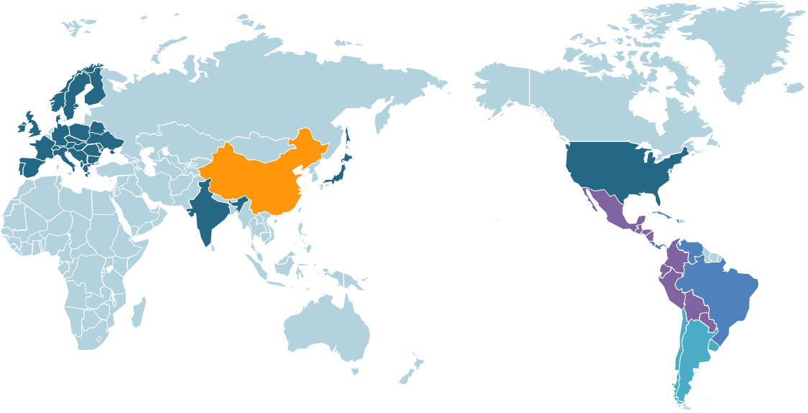
Figure 1. World map.

3. Findings

This topic addresses the expectations of Chinese entrepreneurs for the OBOR initiative. In the event that what your expectations coincide with the objectives of the same that were previously analyzed, its direct impact would be contrasted. Otherwise, the impact of the initiative would not correspond to its objectives, and could even be null or negative on these Chinese entrepreneurs...
Table 1. Considerations of the entrepreneurs of Chinese SMEs in Spain before OBOR.
Title 1 | Title 2 | Title 3 | Title 4
entry 1 * | data | data | data
 | data | data | data
 | data | data | data
entry 2 | data | data | data
 | data | data | data
entry 3 | data | data | data
 | data | data | data
 | data | data | data
 | data | data | data
entry 4 | data | data | data
 | data | data | data
* Tables may have a footer.

but rather focus more on theories, therefore, until now the specific impacts of this initiative on Chinese entrepreneurs have not been clarified...

4. Discussions and Prospects

1) There are two groups of entrepreneurs that show significantly different perceptions regarding the OBOR Initiative and its impact: a). There is a group (group A) that is well informed about the initiative, although they are not able to present it in their own words, they show their approval of OBOR, they confirm its importance and success, they also state that they have received its influence on a certain level; b). Another group (group B), do not have sufficient knowledge of the initiative, nor do they show interest in it and when being informed during the interview about its objectives and what is disseminated about it in the official discourse, they express their distrust of the initiative and the Chinese authorities. This group does not consider to have received any impact from the initiative, and their possible expectations in OBOR are very varied and unrealistic...

Bibliografía
(Beltrán 2009) Beltrán A. J. 2009. La inmigración china en Cataluña. Visions de la Xina: cultura mil· lenària, 125-150.
(Beltrán 2007) Beltrán A J. 2007. El transnacionalismo en el empresariado asiático de España. Revista CIDOB d'afers internacionals, 13-32.
(China Daily 2019) China Daily. 2019. Overseas Chinese Official Report Released [N/OL], Available online: https://cn.chinadaily.com.cn/a/201912/20/WS5dfca964a31099ab995f2da0.html (accessed on 19 Nov 2020) (In Chinese).
(Ferrer 2020) Ferrer, M.S. 2020. Los chinos son la comunidad de extranjeros con más trabajadores autónomos, [EB/OL], Available online: https://www.uoc.edu/portal/es/news/actualitat/2020/116-chinos-autonomos.html (accessed on 19 Nov 2020).
(Wang 2019) Wang Z.G. 2019. Breakthrough and innovation: development strategies of Chinese enterprises in Spain after the 2008 economic crisis. Studies in the History of Chinese Overseas, (03): 49-59 (In Chinese)
Consultation of the Denomination File. Available online: https://sede.mir.gob.es/opencms/export/sites/default/es/procedimientos-y-servicios/tramites-sobre-asociaciones-inscritas/consulta-del-fichero-de-denominaciones-de-asociaciones/ (accessed on 19 Nov 2020).

